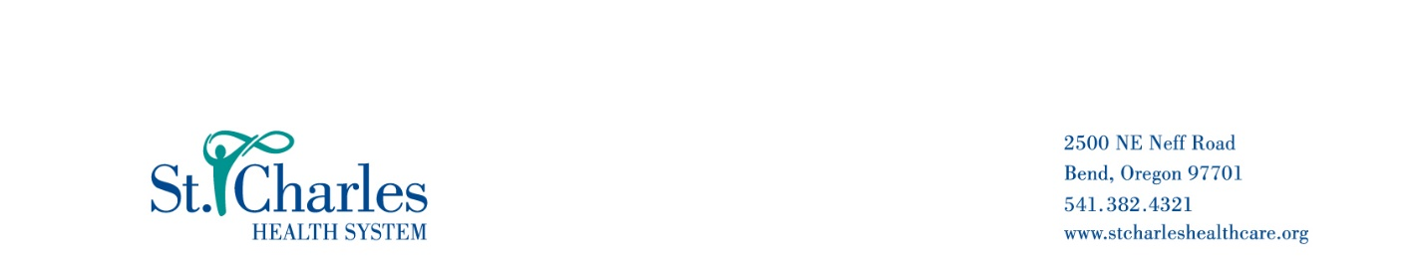
September 11, 2023,

Laboratory Memo: Ordering the Aptima Vaginosis Assay

Dear Provider,

SCHS Laboratory requests that you only order the panels listed below when medically necessary, that being when the patient is symptomatic. The Aptima test is not intended for the purpose of STI screening.

Orderable panels:
- Aptima Vaginitis Assay by NAA
- Chlamydia/GC Aptima Vaginitis Assay by NAA

These panels contain the component “Gardnerella vaginalis (81513)” that is not appropriate for a STI screening, patients must meet the medical necessity for symptomatic individuals.

On behalf of St. Charles Laboratories, we appreciate the opportunity to serve you and your patients.

If there are any questions, please contact:

Wendy Capps Laboratory Support Services Supervisor 541-706-6387

Sharon Reams MT (ASCP) Laboratory Manager of Operations 541-706-2798

